Title of report: Data Cleaning Task
Prepared for: Mr Umair
Prepared by: Mohsin Saeed
08-Jun-26

Contents
Objective 3
Learning and Outcomes 3
Challenges 3
1. Replace Error and Unknown Values 3
2. Remove Duplicate Values 3
3. Map Column Data Using Enumerate and Map Function 4
4. Split Date Column 4
5. Balance Data Using Groupby, Sample and Reset Index 4
6. Data Visualization Using Matplotlib and Seaborn 4
Data Cleaning Techniques 4
1. Remove Null Values 4
2. Remove Duplicate Values 4
3. Replace Error and Unknown Values 5
4. Drop Unnecessary Columns 5
5. Map and Enumerate 5
6. Column Data Type Conversion 5
7. Balance Target Column 5
8. Graphs Before and After Data Cleaning 5
Conclusion 5

Objective
The objective of this task was to perform data cleaning and preprocessing on a real-world dataset containing Orders data across multiple cities. The goal was to prepare the data for further analysis and machine learning by handling errors, inconsistencies, imbalances, and visualizing the results.

Learning and Outcomes
Learned how to identify and replace error and unknown values in a dataset
Understood how to remove duplicate rows to ensure data quality
Applied enumerate and map functions to encode categorical columns numerically
Practiced splitting date columns into separate components for feature extraction
Successfully balanced an imbalanced dataset using groupby, sample, and reset_index
Gained hands-on experience in data visualization using Matplotlib and Seaborn including bar plots, box plots and histograms

Challenges

1. Replace Error and Unknown Values
Replaced error and unknown values in the dataset with NaN and then handled them appropriately to ensure data consistency.

2. Remove Duplicate Values
Identified and removed duplicate rows from the dataset to ensure data quality.

3. Map Column Data Using Enumerate and Map Function
Used enumerate to assign numerical indices to unique categorical values and mapped them using a dictionary for label encoding.

4. Split Date Column
Split the date column into separate day, month, and year components for better feature extraction.

5. Balance Data Using Groupby, Sample and Reset Index
Balanced the dataset by sampling equal number of rows from each city group to remove class imbalance.

6. Data Visualization Using Matplotlib and Seaborn
Visualized the data distribution before and after balancing using bar plots, box plots, and histograms. 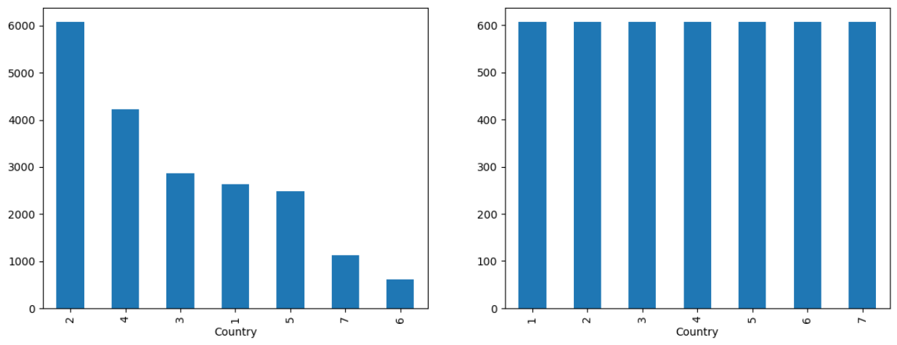

Data Cleaning Techniques

1. Remove Null Values
Null values were identified and removed from the dataset to ensure no missing data affects the analysis or model training process.

2. Remove Duplicate Values
Duplicate rows were detected and eliminated to prevent redundancy and ensure each record is unique.

3. Replace Error and Unknown Values
Inconsistent string values such as "ERROR" and "UNKNOWN" were replaced with NaN and subsequently handled to maintain data integrity.

4. Drop Unnecessary Columns
Columns that do not contribute to model training such as Transaction ID and Date were dropped to reduce noise and improve model performance.

5. Map and Enumerate
Categorical columns were encoded numerically using enumerate and map functions to convert text values into machine readable format.

6. Column Data Type Conversion
Object type columns were converted to appropriate data types to ensure compatibility with machine learning models.

7. Balance Target Column
The target column was balanced using groupby and lambda sampling to resolve class imbalance and prevent model bias toward majority class.

8. Graphs Before and After Data Cleaning
Data distribution was visualized before and after cleaning using Matplotlib and Seaborn to confirm successful preprocessing.

Conclusion
This task successfully completed end-to-end data preprocessing using NumPy, Pandas, Matplotlib, and Seaborn. Null values, duplicates, and inconsistent strings like ERROR and UNKNOWN were removed to ensure data integrity. Unnecessary columns were dropped, categorical variables were encoded using enumerate and map, and data types were converted for model compatibility. Class imbalance was resolved using a custom Pandas groupby with lambda sampling. Data distributions were visualized before and after cleaning, confirming successful preprocessing. The dataset is now clean, balanced, and fully ready for model training.

